What is DBMS?

Database Management Systems (DBMS) are software systems used to store, retrieve, and run queries on data. A DBMS serves as an interface between an end-user and a database, allowing users to create, read, update, and delete data in the database.

DBMS manage the data, the database engine, and the database schema, allowing for data to be manipulated or extracted by users and other programs. This helps provide data security, data integrity, concurrency, and uniform data administration procedures.

DBMS optimizes the organization of data by following a database schema design technique called normalization, which splits a large table into smaller tables when any of its attributes have redundancy in values. DBMS offer many benefits over traditional file systems, including flexibility and a more complex backup system.

Database management systems can be classified based on a variety of criteria such as the data model, the database distribution, or user numbers. The most widely used types of DBMS software are relational, distributed, hierarchical, object-oriented, and network.

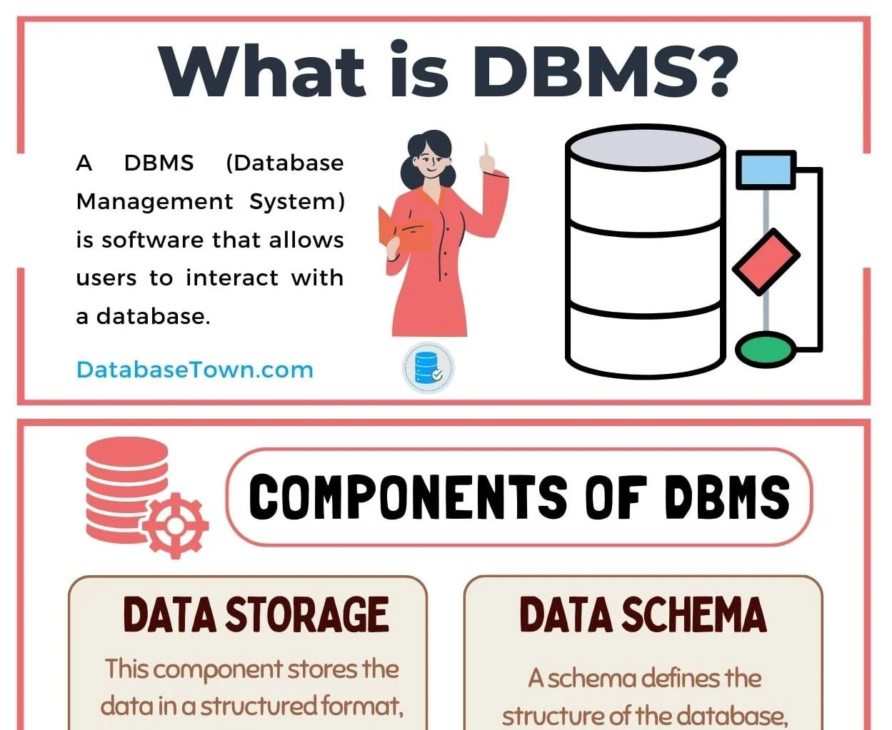

### **Distributed database management system**

A distributed DBMS is a set of logically interrelated databases distributed over a network that is managed by a centralized database application. This type of DBMS synchronizes data periodically and ensures that any change to data is universally updated in the database.

### **Hierarchical database management system**

Hierarchical databases organize model data in a tree-like structure. Data storage is either a top-down or bottom-up format and is represented using a parent-child relationship.

### **Network database management system**

The network database model addresses the need for more complex relationships by allowing each child to have multiple parents. Entities are organized in a graph that can be accessed through several paths.

### **Relational database management system**

Relational database management systems (RDBMS) are the most popular data model because of its user-friendly interface. It is based on normalizing data in the rows and columns of the tables. This is a viable option when you need a data storage system that is scalable, flexible, and able to manage lots of information.

### **Object-oriented database management system**

Object-oriented models store data in objects instead of rows and columns. It is based on object-oriented programming (OOP) that allows objects to have members such as fields, properties, and methods.

## Examples of DBMS

There is a wide range of database software solutions, including both enterprise and open source solutions, available for database management.

Here are some of the most popular database management systems:

### **Oracle**

Oracle Database is a commercial relational database management system. It utilizes enterprise-scale database technology with a robust set of features right out of the box. It can be stored in the cloud or on-premises.

### **MySQL**

MySQL is a relational database management system that is commonly used with open-source content management systems and large platforms like Facebook, Twitter, and Youtube.

### **SQL Server**

Developed by Microsoft, SQL Server is a relational database management system built on top of structured query language (SQL), a standardized programming language that allows database administrators to manage databases and query data. Database Management Systems (DBMS) have several characteristics that distinguish them from other types of software or data management systems. Some key characteristics include:

1. **Data Independence**: DBMS provides abstraction from the physical storage details of data. This means that changes in the physical storage structure do not affect the applications using the data.
2. **Data Integrity**: DBMS enforces data integrity constraints to ensure that data remains accurate and consistent. This includes features like primary keys, foreign keys, and constraints that maintain data validity.
3. **Concurrency Control**: DBMS manages concurrent access to data by multiple users or processes to ensure data consistency and integrity. This involves mechanisms such as locking and transaction management.
4. **Data Security**: DBMS provides security mechanisms to control access to data and protect it from unauthorized access or modifications. This includes user authentication, authorization, and encryption techniques.
5. **Data Recovery and Backup**: DBMS includes features for data backup and recovery to ensure data availability in case of system failures, crashes, or other disasters.
6. **Query Language**: DBMS supports a query language (e.g., SQL - Structured Query Language) for retrieving, manipulating, and managing data stored in the database.
7. **Scalability**: DBMS is designed to handle growing amounts of data and increasing numbers of users or transactions without sacrificing performance or reliability.
8. **ACID Properties**: DBMS ensures transactional consistency by adhering to ACID properties - Atomicity, Consistency, Isolation, and Durability.
9. **Data Abstraction**: DBMS provides different levels of abstraction for users, including physical, logical, and view levels, allowing users to interact with data at a level appropriate for their needs without worrying about underlying complexities.
10. **Optimization**: DBMS includes query optimization techniques to enhance performance by selecting the most efficient execution plans for queries.

These characteristics collectively make DBMS a powerful tool for efficiently managing and manipulating large volumes of data in various applications and domains.

## +

## What is RDBMS?

RDBMS stands for Relational Database Management Systems. It is basically a program that allows us to create, delete, and update a relational database. A Relational Database is a database system that stores and retrieves data in a tabular format organized in the form of rows and columns. It is a smaller subset of DBMS which was designed by E.F Codd in the 1970s. The major [DBMSs](https://www.geeksforgeeks.org/introduction-of-dbms-database-management-system-set-1/) like[SQL, My-SQL](https://www.geeksforgeeks.org/sql-vs-mysql/), and [ORACLE](https://www.geeksforgeeks.org/oracle-architecture/)are all based on the principles of relational DBMS.

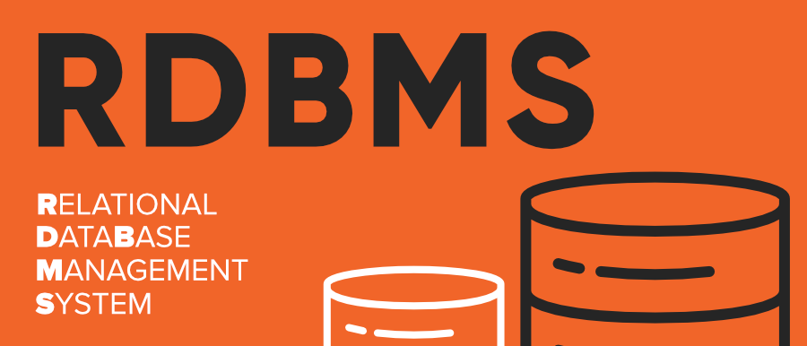

Relational Database Management Systems maintains data integrity by simulating the following features:

* **Entity Integrity:** No two records of the database table can be completely duplicate.
* **Referential Integrity:** Only the rows of those tables can be deleted which are not used by other tables. Otherwise, it may lead to [data inconsistency](https://www.geeksforgeeks.org/what-is-data-inconsistency-in-dbms/).
* **User-defined Integrity:** Rules defined by the users based on confidentiality and access.
* **Domain integrity:**The columns of the database tables are enclosed within some structured limits, based on default values, type of data or ranges.

## Characteristics of RDBMS

* Data must be stored in tabular form in DB file, that is, it should be organized in the form of rows and columns.
* Each row of table is called [record/tuple](https://www.geeksforgeeks.org/tuple-in-dbms/) . Collection of such records is known as the cardinality of the table
* Each column of the table is called an attribute/field. Collection of such columns is called the arity of the table.
* No two records of the DB table can be same. Data duplicity is therefore avoided by using a candidate key. [Candidate Key](https://www.geeksforgeeks.org/candidate-key-in-dbms/)is a minimum set of attributes required to identify each record uniquely.
* Tables are related to each other with the help for foreign keys.
* Database tables also allow NULL values, that is if the values of any of the element of the table are not filled or are missing, it becomes a NULL value, which is not equivalent to zero. (NOTE: [Primary key](https://www.geeksforgeeks.org/primary-key-in-dbms/) cannot have a NULL value).

## Examples of Relational Database

Let’s discuss these relational databases briefly.

### Microsoft SQL Server

Microsoft SQL Server is a relational database management system (RDBMS) developed by Microsoft. As a database server, it is a software product with the primary function of storing and retrieving data as requested by other software applications—which may run either on the same computer or on another computer across a network (including the Internet).

### MySQL

MySQL is a widely used, open-source relational database management system (RDBMS). MySQL is free and open-source software under the terms of the GNU (General Public License) and is also available under a variety of proprietary licenses.

### PostgreSQL

PostgreSQL, often simply Postgres, is an object-relational database management system (ORDBMS) with an emphasis on extensibility and standards compliance. It is free and open-source software released under the PostgreSQL License.

### SQLite

SQLite is a relational database management system contained in a C programming library. In contrast to many other database management systems, SQLite is not a client–server database engine. Rather, it is embedded into the end program. SQLite is ACID-compliant and implements most of the SQL standard, using a dynamically and weakly typed SQL syntax that does not guarantee the domain integrity.

SQLite is one of the most widely deployed database engines, as it is used today by several widespread browsers, operating systems, and embedded systems, among others. Heavily used in iPhone applications, it features full-text search and geospatial query support.

### Oracle Database

Oracle Corporation’s Oracle database is a relational database management system (RDBMS) that runs on major platforms like Linux, UNIX, and Windows. It is very popular relational database and is known for its scalability, reliability, and performance.

### MariaDB

MariaDB is an open-source relational database management system (RDBMS) that’s compatible with the popular MySQL database. MariaDB is used by organizations of all sizes, from small businesses to some of the largest companies in the world.

### IBM Informix

Informix was one of the first commercial relational database products on the market; it was designed to run on mainframe computers in 1982 but was subsequently ported to Unix, Linux, macOS and Windows platforms as well. It was acquired by IBM in 2001 along with other assets from Informix Software for $1 billion USD cash plus $250 million stock options. Its stable release date is 17 November 2020.

### Apache Derby

Apache Derby is an open source relational database management system that is written in Java and runs on any platform that supports Java Runtime Environment (JRE). It is lightweight and easy to use, making it a good choice for developing small databases or prototypes.

### H2 Database Engine

H2 Database Engine is another open source relational database management system written in Java that can be used in embedded or server mode. It offers a simple interface and powerful features making it a good choice for small applications or prototyping purposes.

### Amazon Relational Database Service (Amazon RDS)

Amazon RDS is Amazon’s managed relational database service that supports popular databases such as MySQL, PostgreSQL, MariaDB, Oracle, and Microsoft SQL Server. Amazon RDS makes it easy to set up, operate, and scale a relational database in the cloud.

### Sybase ASE

Sybase ASE (Adaptive Server Enterprise) is a relational model database server produced by Sybase Corporation (now part of SAP). It primarily runs on UNIX systems. It was ported to Microsoft Windows NT also. It’s known for its robust transactional processing capabilities.

### DB2

IBM DB2 is a family of hybrid data management products designed to serve a range of workloads including transactional processing, data warehousing, business intelligence and analytics. The IBM DB2 family offers IBM Hybrid Data Management solutions for managing both structured and unstructured data – on premise or in any cloud environment.

It offers a number of features to help improve performance and scalability, including query optimization, indexing and partitioning.

### Microsoft Access

Microsoft Access is a database management system (DBMS) from Microsoft that combines the relational Microsoft Jet Database Engine with a graphical user interface and software-development tools.

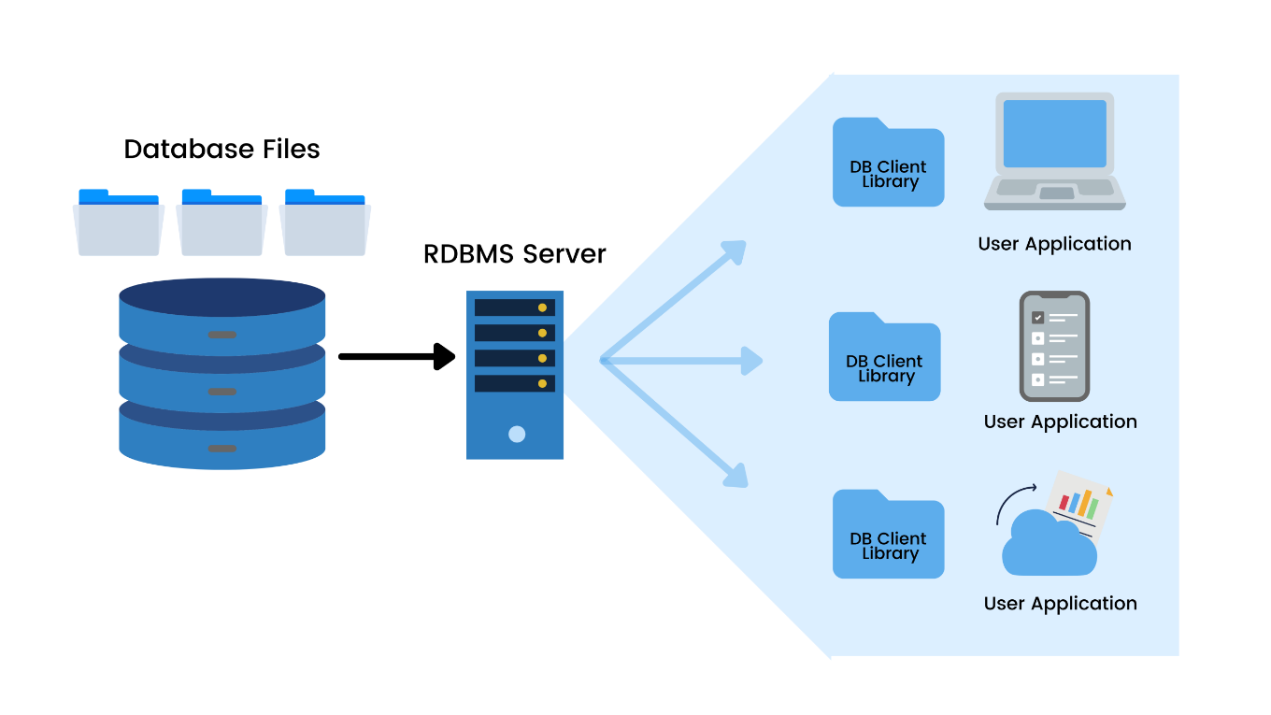

Difference Between DBMS vs RDBMS

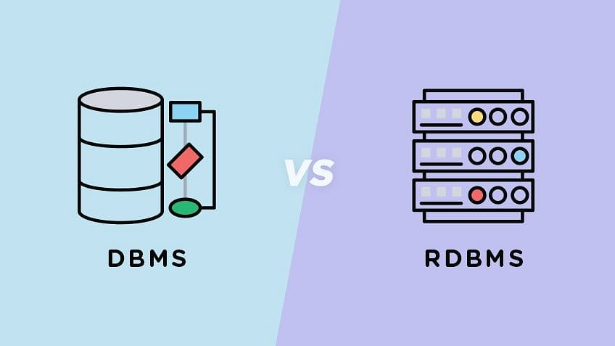

| **DBMS** | **RDBMS** |
| --- | --- |
| [DBMS](https://www.geeksforgeeks.org/introduction-of-dbms-database-management-system-set-1/) stores data as file. | [RDBMS](https://www.geeksforgeeks.org/rdbms-architecture/) stores data in tabular form. |
| Data elements need to access individually. | Multiple data elements can be accessed at the same time. |
| No relationship between data. | Data is stored in the form of tables which are related to each other. |
| Normalization is not present. | Normalization is present. |
| DBMS does not support distributed database. | RDBMS supports distributed database. |
| It stores data in either a navigational or hierarchical form. | It uses a tabular structure where the headers are the column names, and the rows contain corresponding values. |
| It deals with small quantity of data. | It deals with large amount of data. |
| Data redundancy is common in this model. | Keys and indexes do not allow Data redundancy. |
| It is used for small organization and deal with small data. | It is used to handle large amount of data. |
| Not all Codd rules are satisfied. | All 12 Codd rules are satisfied. |
| Security is less | More security measures provided. |
| It supports single user. | It supports multiple users. |
| Data fetching is slower for the large amount of data. | Data fetching is fast because of relational approach. |
| The data in a DBMS is subject to low security levels with regards to data manipulation. | There exists multiple levels of data security in a RDBMS. |
| Low software and hardware necessities. | Higher software and hardware necessities. |
| Examples:[XML](https://www.geeksforgeeks.org/xml-basics/), Window Registry, Forxpro, dbaseIIIplus etc. | Examples: [MySQL](https://www.geeksforgeeks.org/architecture-of-mysql/), [PostgreSQL](https://www.geeksforgeeks.org/what-is-postgresql-introduction/), [SQL](https://www.geeksforgeeks.org/what-is-sql/) Server, Oracle, Microsoft Access etc. |

Database Management Systems (DBMS) have several characteristics that distinguish them from other types of software or data management systems. Some key characteristics include:

1. **Data Independence**: DBMS provides abstraction from the physical storage details of data. This means that changes in the physical storage structure do not affect the applications using the data.
2. **Data Integrity**: DBMS enforces data integrity constraints to ensure that data remains accurate and consistent. This includes features like primary keys, foreign keys, and constraints that maintain data validity.
3. **Concurrency Control**: DBMS manages concurrent access to data by multiple users or processes to ensure data consistency and integrity. This involves mechanisms such as locking and transaction management.
4. **Data Security**: DBMS provides security mechanisms to control access to data and protect it from unauthorized access or modifications. This includes user authentication, authorization, and encryption techniques.
5. **Data Recovery and Backup**: DBMS includes features for data backup and recovery to ensure data availability in case of system failures, crashes, or other disasters.
6. **Query Language**: DBMS supports a query language (e.g., SQL - Structured Query Language) for retrieving, manipulating, and managing data stored in the database.
7. **Scalability**: DBMS is designed to handle growing amounts of data and increasing numbers of users or transactions without sacrificing performance or reliability.
8. **ACID Properties**: DBMS ensures transactional consistency by adhering to ACID properties - Atomicity, Consistency, Isolation, and Durability.
9. **Data Abstraction**: DBMS provides different levels of abstraction for users, including physical, logical, and view levels, allowing users to interact with data at a level appropriate for their needs without worrying about underlying complexities.
10. **Optimization**: DBMS includes query optimization techniques to enhance performance by selecting the most efficient execution plans for queries.

These characteristics collectively make DBMS a powerful tool for efficiently managing and manipulating large volumes of data in various applications and domains.

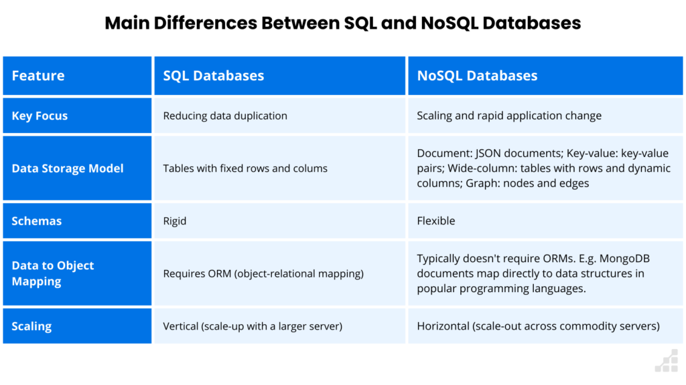

Top of Form

Bottom of Form